How I made the circuits in Proteus
1. I went to the ‘Component mode’ tab and the P checkbox/icon and then searched the RES, and BATTERY and placed it in the sheet.
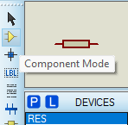
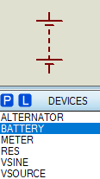
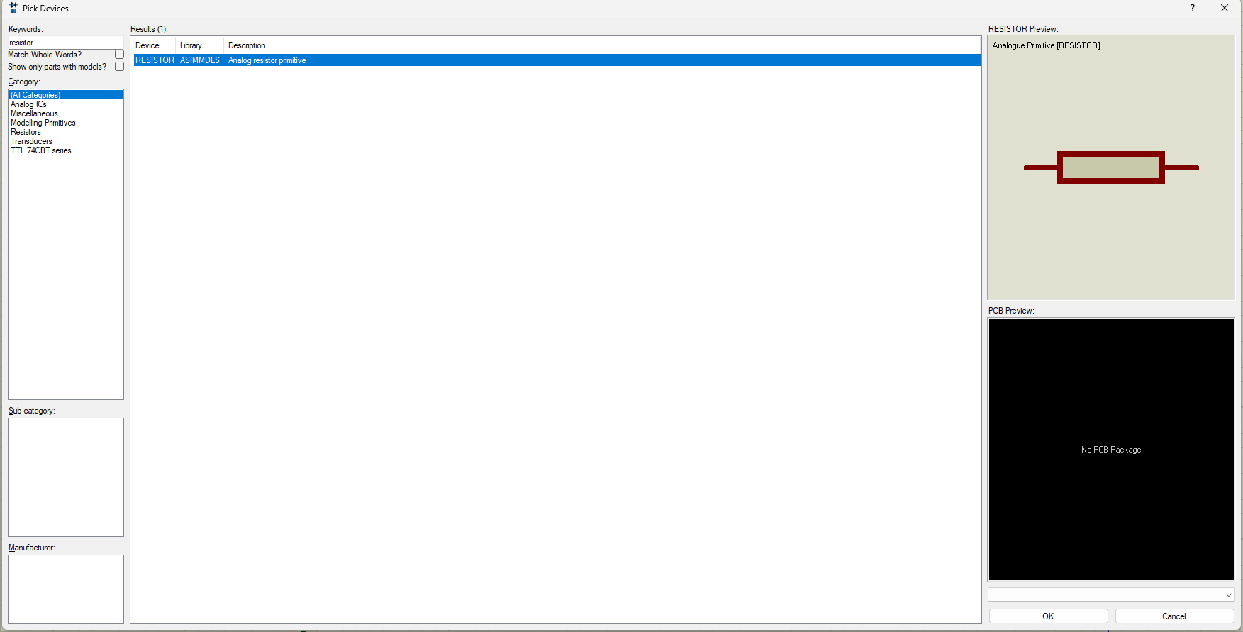
2. Then I went to ‘Instrument’ tab and drop the DC AMMETER and DC VOLTMETER in the sheet.
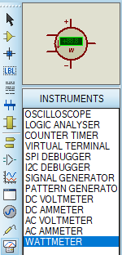
3. I then connected the resistors in the by drawing a wire with mouse and changed the value of their resistances.

Circuit 1
4. Then I connected the of the BATTERY to the circuit and also connected ammeter in series to R1, R2 and R3.
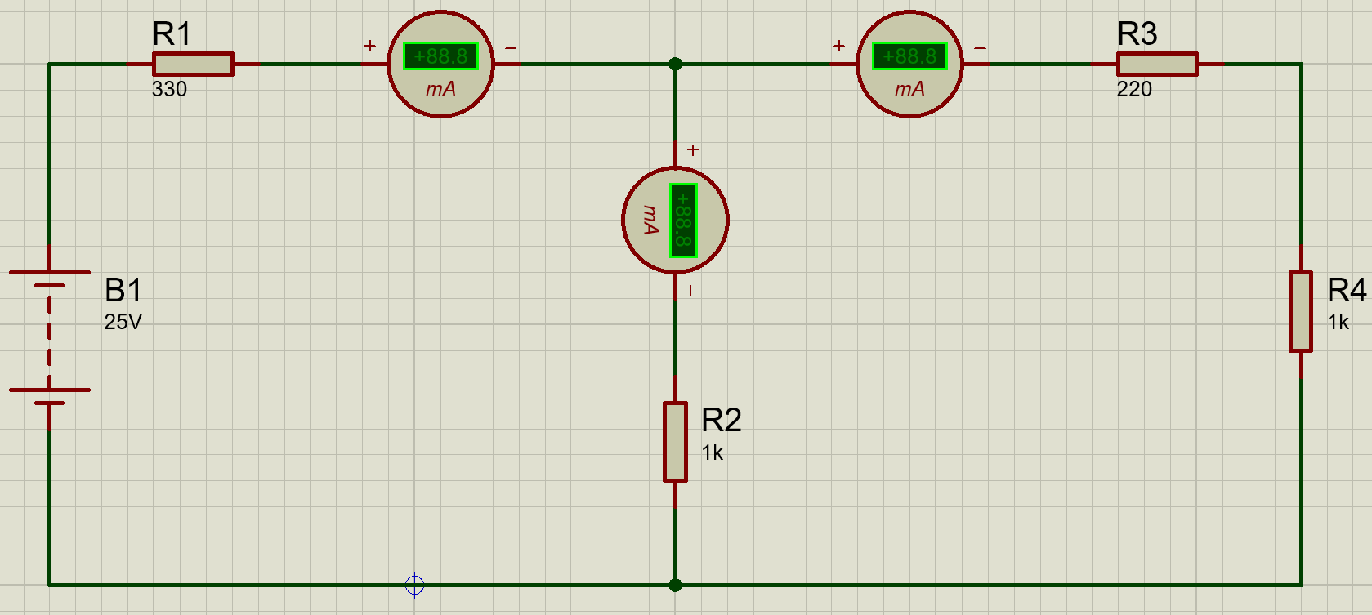
Circuit 2
4. Then I connected the Battery to the circuit, connected the voltmeter in parallel with R1, R2 and R3.
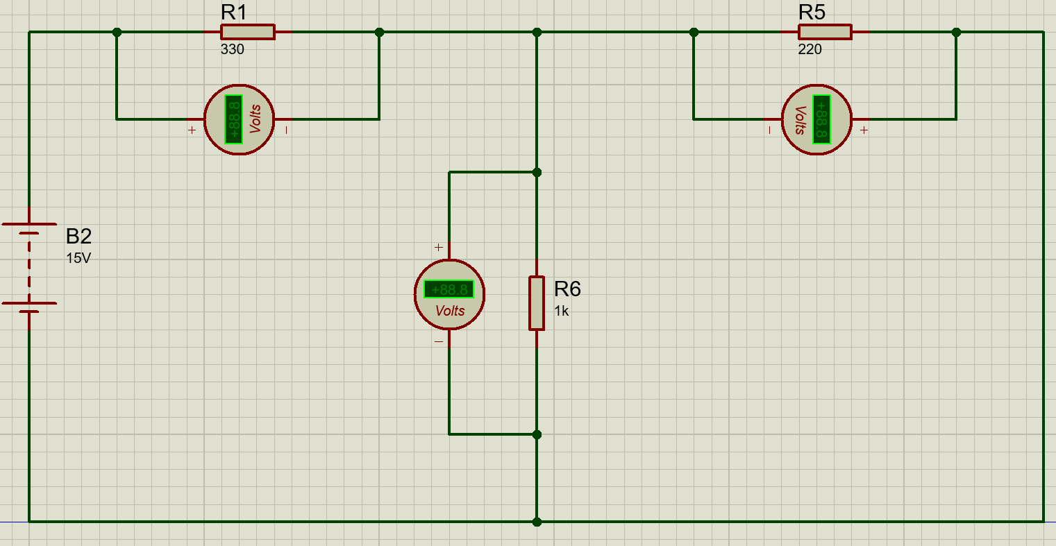
Outputs
Circuit 1
Output 1
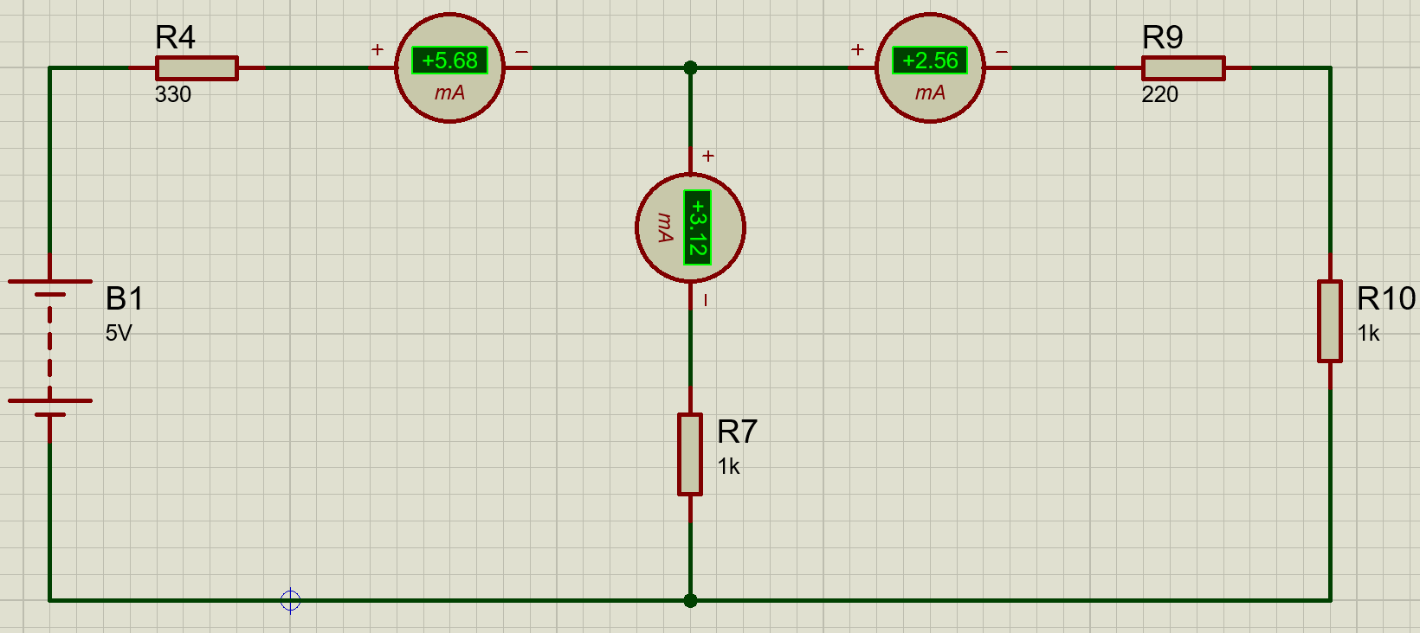
Output 2
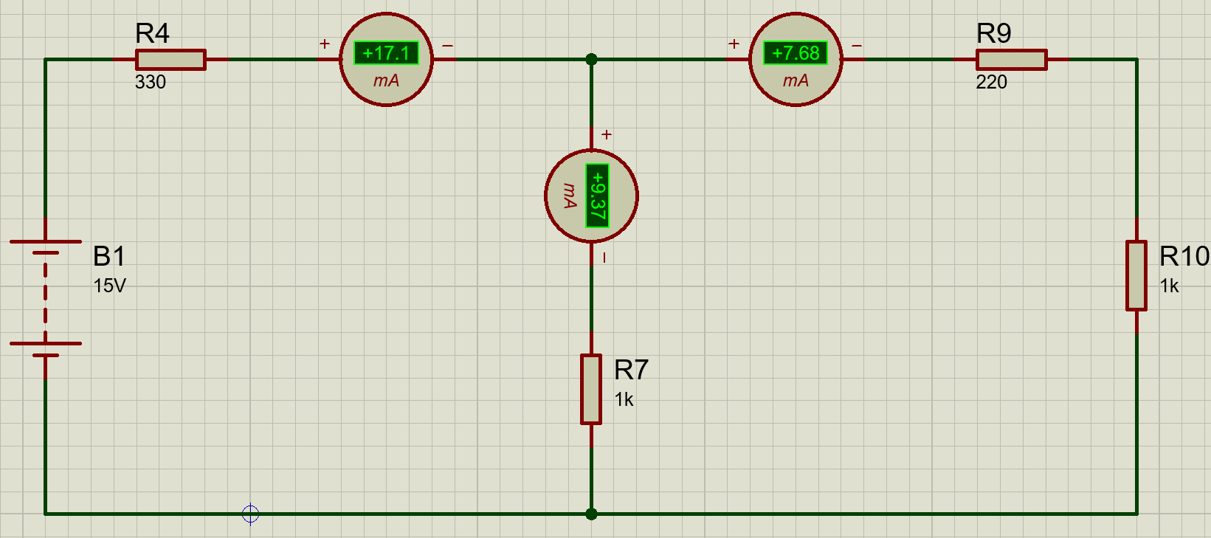
Output 3
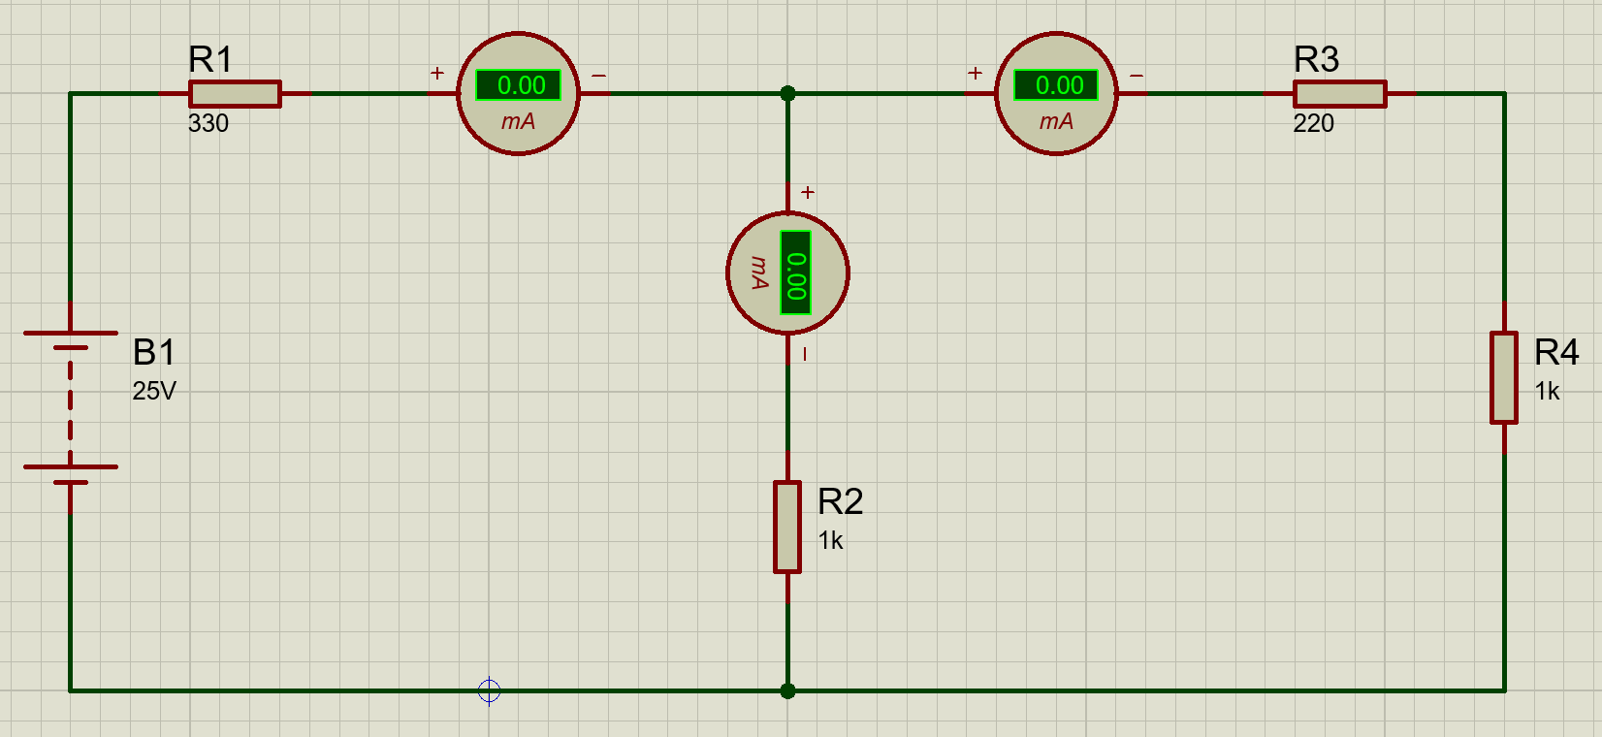
Circuit 2
Output 1
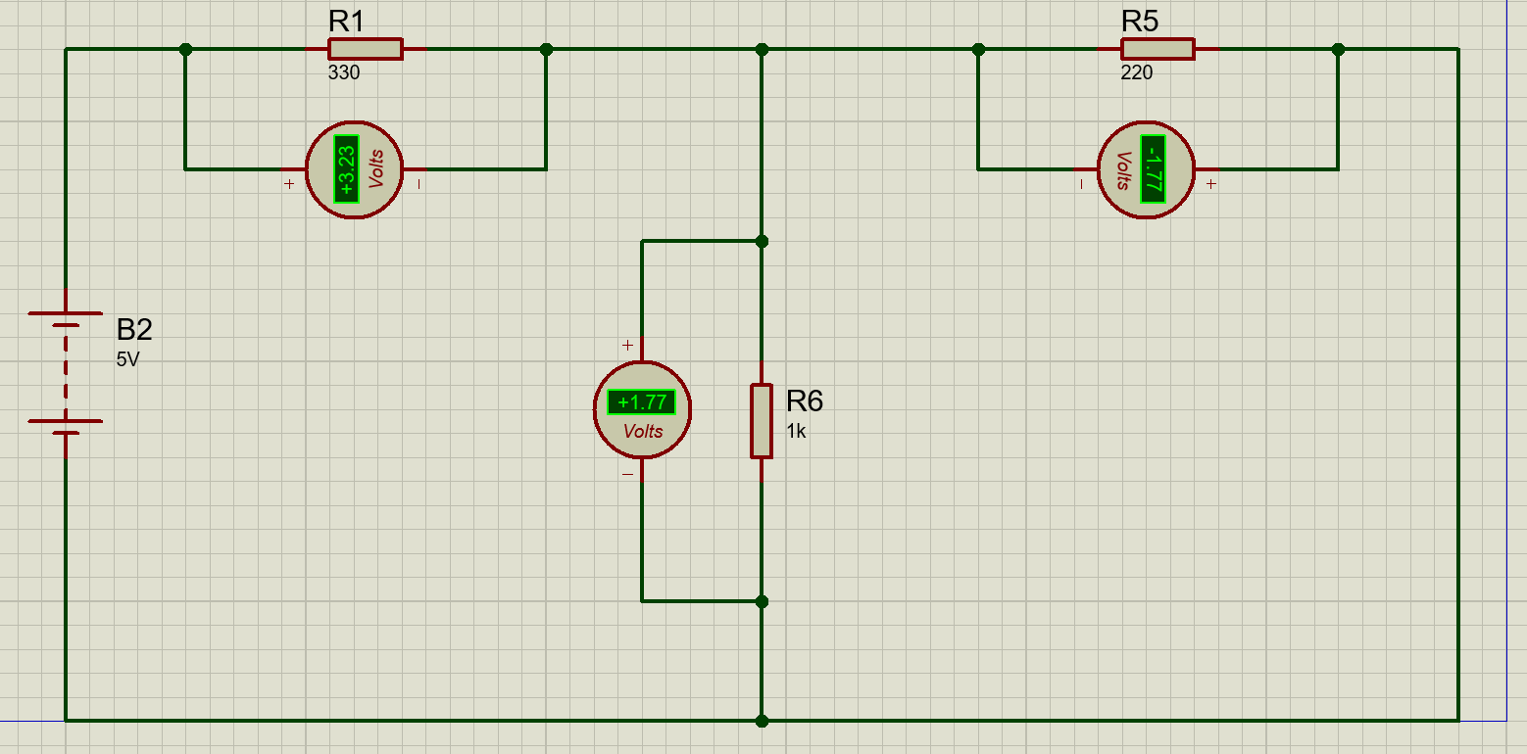
Output 2
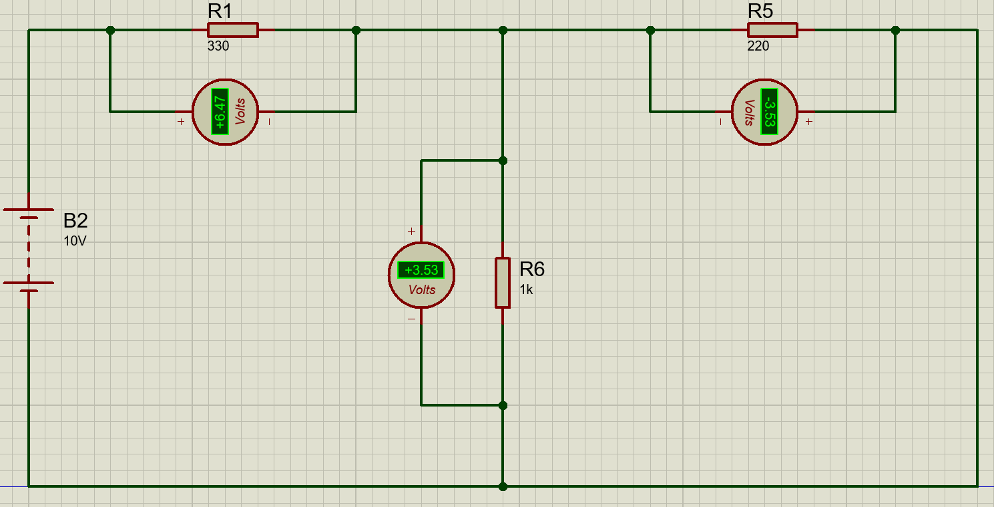
Output 3

